**ECE -1 Lab **

**Experiment - 10**

**Aim:** Encoder Designs for Flash ADC

### Description: Flash ADC with multiplexer-based encoder

Flash ADC is used to convert analog to Digital signals in one cycle. In this experiment we would implement digital to analog and then back to digital conversion. A typical Flash ADC is shown in figure 1, which converts analog value Vin to an N bit digital code. To get the digital codes we have an encoder which would encode 2N – 1 inputs (which are outputs of comparators) to N bits. The upper most comparator would provide the MSB for the digital data and lower most would provide LSB. The outputs of the comparators would be a thermometer code. (A thermometer code is a binary code in which all the Lower significant bits are 1s and higher bits are 0s. Number of 1s present in code represents the decimal equivalent of the code).

Our lab experiment would be based upon designing the thermometer code to binary code encoder. For this purpose various architectures are present.

**A:** One such encoder is multiplexer based encoder. This is shown in figure 2 (for 15 bit to 4 bit encoding). Implement the encoder using a 2x1 MUX as component and structural coding. Your entity should be having 4 bit input X and 4 bit output Z. First you have to convert bit binary input to 15 bit thermometer code and then using structural coding encode these 15 bits to corresponding binary outputs. Show 3 such conversions in your testbench.

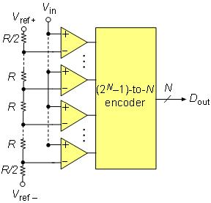 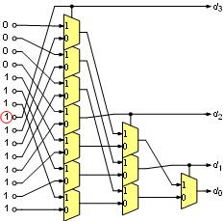

Figure 1 Figure 2.

**B:** Another way to encode the flash ADC output is to use XOR based encoder. This is shown in figure3. This also includes the generation of thermometer codes. Then we attach XOR gates to adjacent bits of thermometer codes to get another code (1 out of n). This code would have only single bit equal to 1 which would be the boundary of 0s and 1s. then use a 8 to 3 line decoder as a component to decode the corresponding binary value.

Fr your entity, you should have 3 bit input X and 3 bit output Z. first X should be converted to thermometer code, then to 1 in n code and then using a decoder as component, encode the binary number back. Show 3 conversions in your testbench.

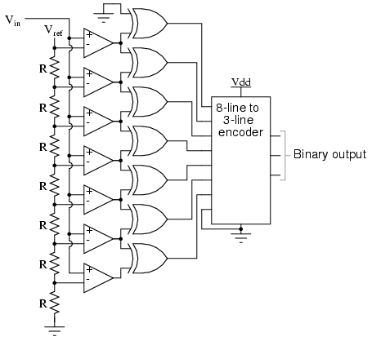

Figure 3